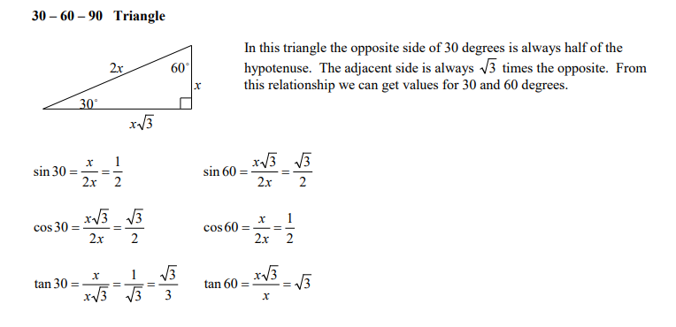
Special Right Triangles

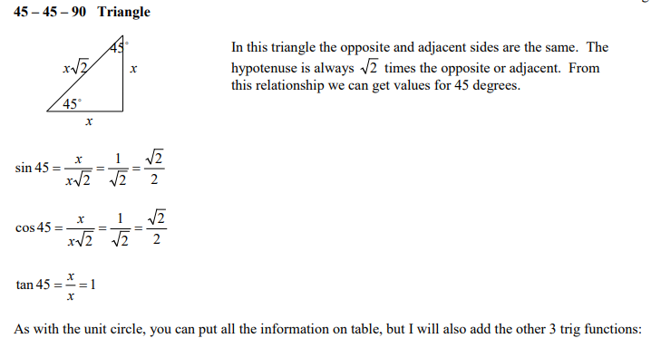

Table of Trig Values
We can put all of the above information into a table.

The last three columns show the reciprocal trig ratios (cosecant, secant and cotangent)
will be examined in a later lesson.
